**Insert Photos/ Map for each POI**

**City - Data**

INSERT INTO `ich`.`inventory_city` (`name`, `state`, `heading1`, `para1`) VALUES ('1', 'Brisbane', 'QLD', 'The Sunshine State', 'Brisbane, capital of Queensland, is a large city on the Brisbane River. Clustered in its South Bank cultural precinct are the Queensland Museum and Sciencentre, with noted interactive exhibitions. Another South Bank cultural institution is Queensland Gallery of Modern Art, among Australia's major contemporary art museums. Looming over the city is Mt. Coot-tha, site of Brisbane Botanic Gardens.');

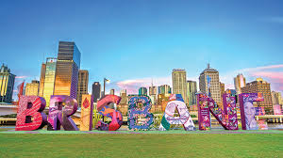

INSERT INTO `ich`.`inventory_city` (`name`, `state`, `heading1`, `para1`) VALUES ('1', 'Melbourne', 'VIC', 'The world’s most livable city', 'Melbourne is the coastal capital of the southeastern Australian state of Victoria. At the city's centre is the modern Federation Square development, with plazas, bars, and restaurants by the Yarra River. In the South bank area, the Melbourne Arts Precinct is the site of Arts Centre Melbourne – a performing arts complex – and the National Gallery of Victoria, with Australian and indigenous art.');

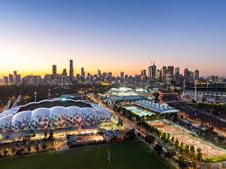

INSERT INTO `ich`.`inventory_city` (`name`, `state`, `heading1`, `para1`) VALUES ('1', 'Sydney', 'NSW', 'Sydney', 'Sydney, capital of New South Wales and one of Australia's largest cities, is best known for its harbourfront Sydney Opera House, with a distinctive sail-like design. Massive Darling Harbour and the smaller Circular Quay port are hubs of waterside life, with the arched Harbour Bridge and esteemed Royal Botanic Garden nearby. Sydney Tower’s outdoor platform, the Skywalk, offers 360-degree views of the city and suburbs.');

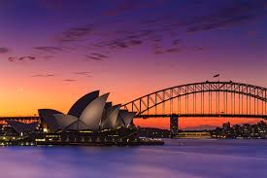

**Colleges**

INSERT INTO `ich`.`inventory_college` (`title`, `address`, `departments`, `email`, `city_id`) VALUES ( 'QUT', 'Gardens Point', 'Law, SEF, Business, Health, Media', 'contact@qut.edu.au', '2', ‘’)

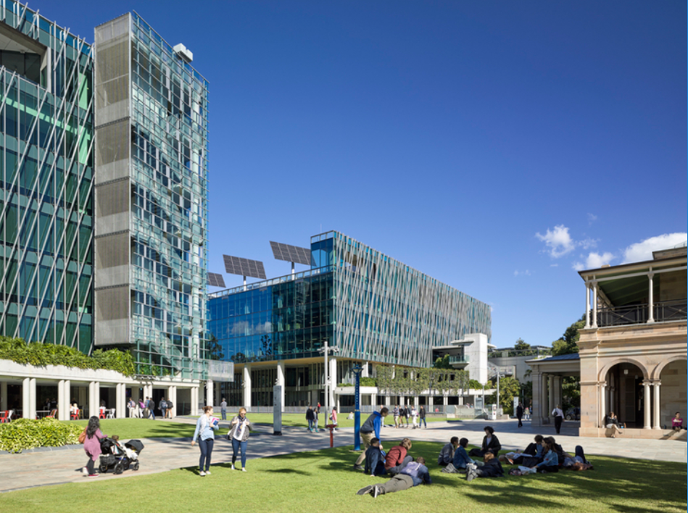

INSERT INTO `ich`.`inventory_college` ( `title`, `address`, `departments`, `email`, `city_id`) VALUES ('UQ', 'St Lucia', 'Law, SEF, Business, Health, Media', 'contact@uq.edu.au', '1',);

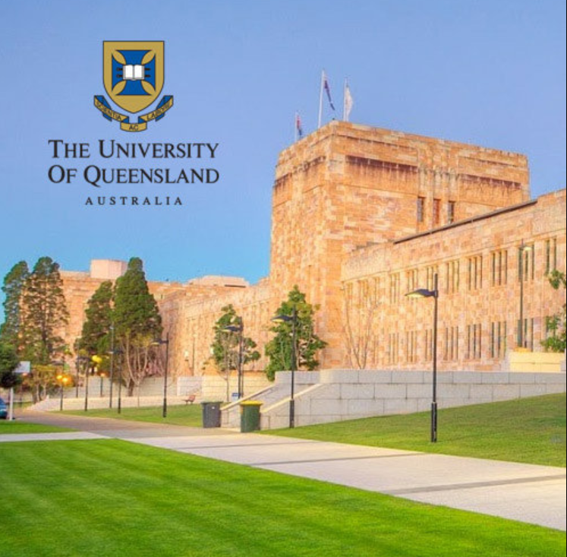

INSERT INTO `ich`.`inventory_college` (`title`, `address`, `departments`, `email`, `city_id`) VALUES ('3', 'Australian Catholic University', 'ACU Brisbane', 'Health', 'health@acubrisbane.com.au', '1',);

INSERT INTO `ich`.`inventory_college` (`title`, `address`, `departments`, `email`, `city_id`) VALUES ( 'Griffth University', 'Mt Gravatt', 'Business', 'mtgravatt@griffth.qld.edu.au', '1');

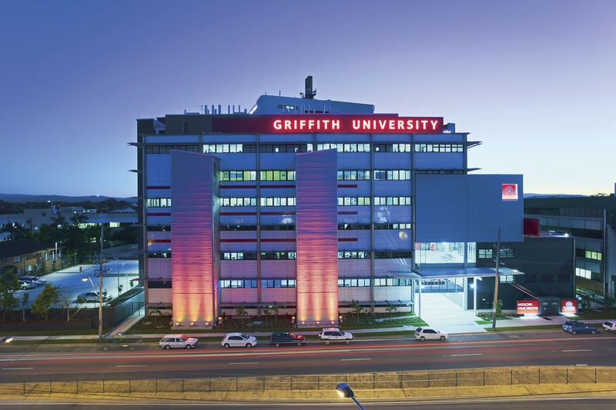

INSERT INTO `ich`.`inventory_college` (, `title`, `address`, `departments`, `email`, `city_id`, `image`) VALUES ('Torrens University Australia', 'Fortitude Valley', 'Creative Industries', ‘torresnuni@education.qld.edu.au', '1', 'a');

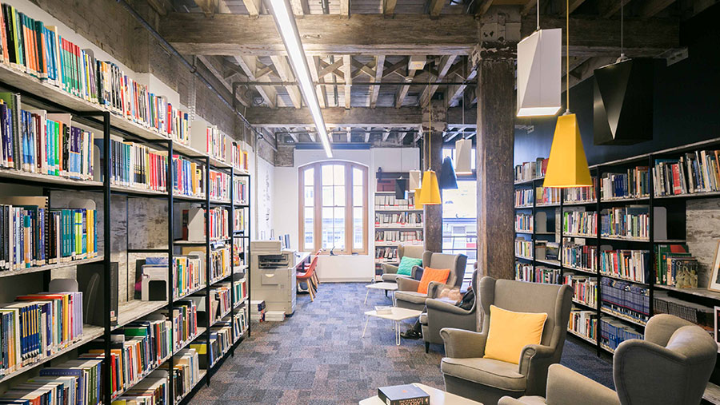

INSERT INTO `ich`.`inventory_college` (`title`, `address`, `departments`, `email`, `city_id`, `image`) VALUES ('Bond University', 'Gold Coast', 'Law, Business, Science, Creative Industries', ‘info@bond.qld.edu.au', '1', 'a');

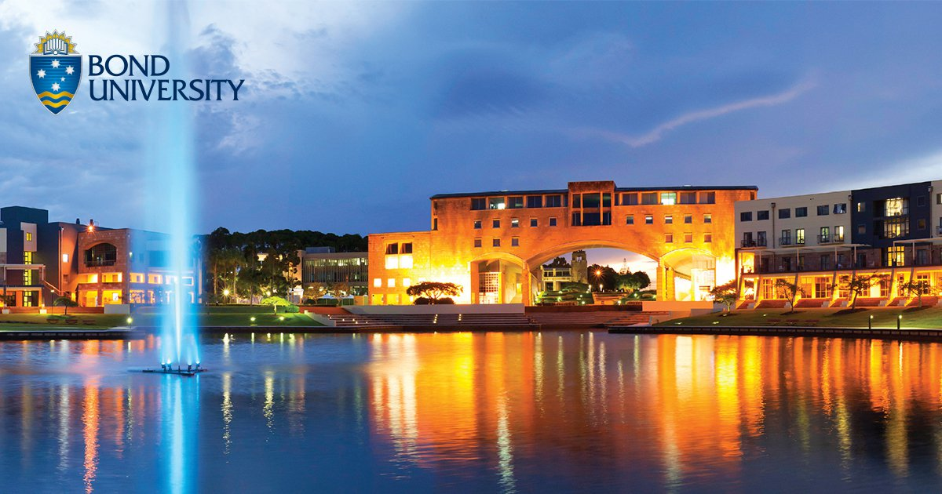

**Cafes**

INSERT INTO `ich`.`inventory_cafe` ( `title`, `address`, `openingHours`, `closingHours`, `description`, `image`, `city_id`) VALUES ( 'BillyKart West End', '2-4 Edmondstone Street', '6am', '3pm', ‘Chef Ben O'Donoghue's second Billykart Kitchen has certainly grown in the past 12 months. The lunch menu is a shorter, sophisticated riff on the newer dinner menu – with old favourites coming off the bench as specials.', 'a', '1');

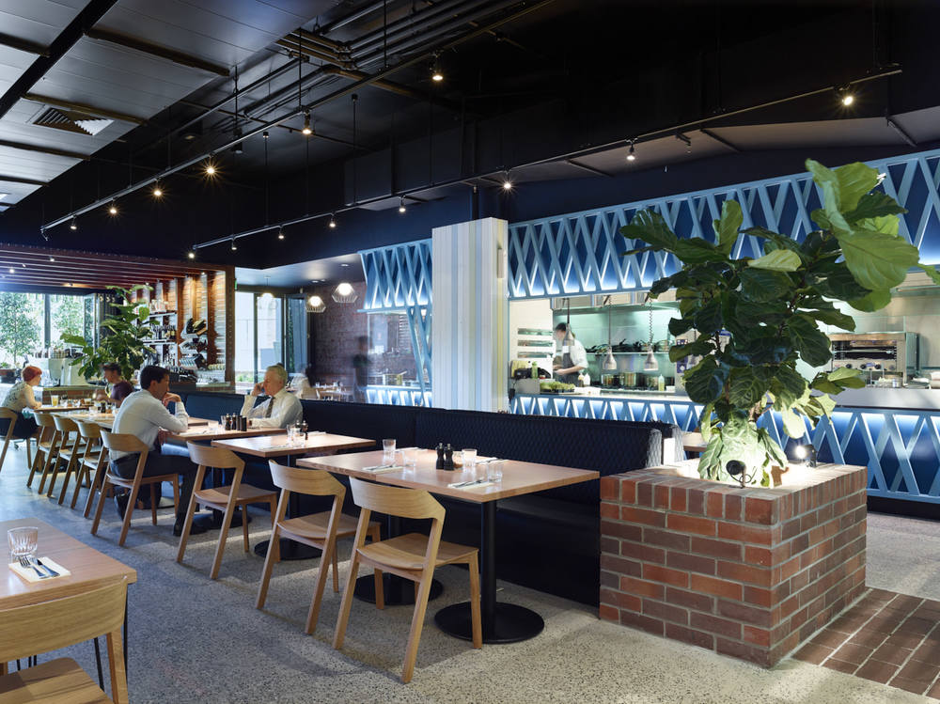

INSERT INTO `ich`.`inventory_cafe` ( `title`, `address`, `openingHours`, `closingHours`, `description`, `image`, `city_id`) VALUES ( 'Cafe O Mai', '15 Cracknell Road, Annerley', '6am', '2pm', 'This Annerley stalwart serves traditional Vietnamese fare all day, and twists Western breakfast classics such as corn fritters and big breakfasts to include pineapple chilli jam and house-made lemongrass pork sausages.', 'a', '1');

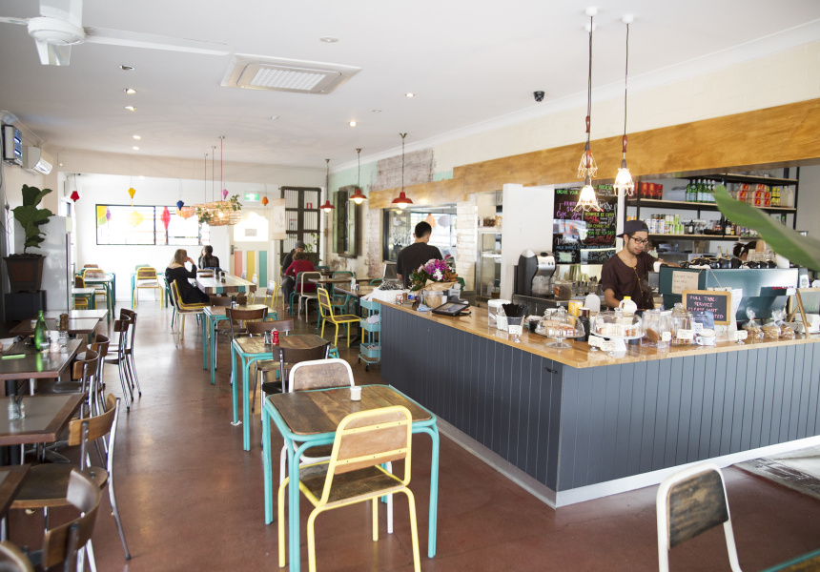

INSERT INTO `ich`.`inventory_cafe` (``title`, `address`, `openingHours`, `closingHours`, `description`, `image`, `city_id`) VALUES ('The Jam Pantry', '164C Arthur Street, Fortitude Valley', '8am', '9pm', 'House-made ferments, jams, pickles and preserves are the Pantry's secret weapon, providing bacon jam on a BLT, eggs on toast with carrot and apple relish, and banana chutney spread over bacon', 'a', '1');

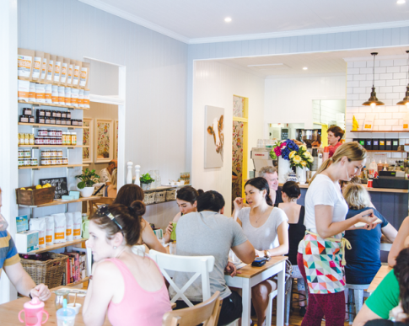

INSERT INTO `ich`.`inventory_cafe` ( `title`, `address`, `openingHours`, `closingHours`, `description`, `image`, `city_id`) VALUES ( 'King Arthur', '575 Logan Road, Greenslopes', '7am', '1pm', 'Opening for dinner on Fridays feels like a long overdue extension for this two-storey warehouse that never really wanted to sit in its breakfast cafe box. Sardines, fish tacos and okonomiyaki play surprisingly nice with well-executed brekkie classics on a evolving locally sourced menu.', 'a', '1');

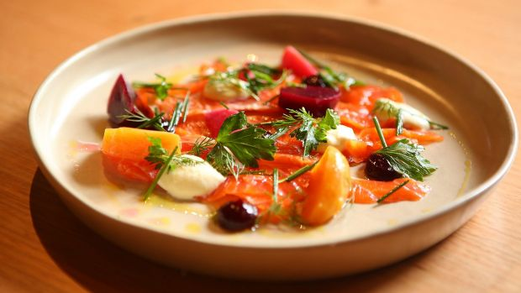

INSERT INTO `ich`.`inventory_cafe` (`title`, `address`, `openingHours`, `closingHours`, `description`, `image`, `city_id`) VALUES ('Marchetti', 'Tattersall's Arcade, 202-210 Edward Street, Brisbane', '9am', '8pm', 'The whiff of strong espresso and an Edith Piaf-esque soundtrack trickling out of an old arcade is a hint at the CBD reprieve to be found in this Art Deco-styled cafe. Marchetti's short menu of humble Italian dishes can be exemplified with a bowl of heart-warming eggplant parmigiana – made with love and served with an accent.', 'a', '1');

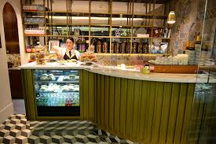

INSERT INTO `ich`.`inventory_cafe` (`title`, `address`, `openingHours`, `closingHours`, `description`, `image`, `city_id`) VALUES ('Naim', '4 Collingwood Street, Paddington', '6am', '2pm', 'Formerly known as Shouk, the same spice-laden journey begins in the Queenslander cottage with epic treetop views from the back room. The latke stack is gone – instead you can use wedges of flatbread to scoop creamy hummus and spiced lamb mince. Shakshuka with merguez is for all time, too.', 'a', '1');

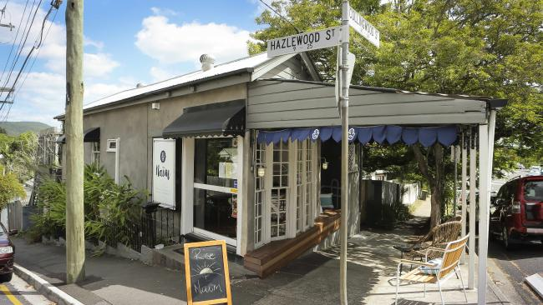

INSERT INTO `ich`.`inventory_cafe` ( `title`, `address`, `openingHours`, `closingHours`, `description`, `image`, `city_id`) VALUES ( 'Pearl Cafe', '28 Logan Road, Woolloongabba', '6am', '2pm', 'There's a humble warmth to Pearl. A La Marzocco pours Allpress coffee at one end of a curved counter while the other is stacked with gorgeous home-style cakes. Walnut-coloured bistro chairs and brass-trimmed tables make for a European vibe. A fluffy ricotta pancake with mascarpone cream is as comforting as a bowl of pork and fennel meatballs in tomato and bean sugo.', 'a', '1');

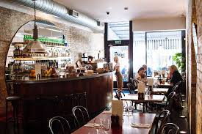

INSERT INTO `ich`.`inventory_cafe` ( `title`, `address`, `openingHours`, `closingHours`, `description`, `image`, `city_id`) VALUES ('Pourboy', '271 Grey Street, South Brisbane', '6am', '2pm', 'While switching from north to south of the river is akin to coming out as a Blues supporter for most Brisbanites, it's given a new life to this former CBD favourite. The delicious breakfast panino now shares a menu with more complex breakfast and dinner-worthy lunch options and the fitout is South Bank swish, pairing excellent coffee from Sydney's Mecca roasters with comfortable seating for the first time in Pourboy's history.', 'a', '1');

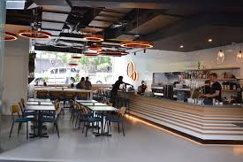

**Hotels:**

INSERT INTO `ich`.`inventory_hotel` (`id`, `title`, `address`, `openingHours`, `closingHours`, `description`, `image`, `city_id`) VALUES ('Pullman', '200 Queen St', '12:00am', '9:00pm', 'Beautiful Hotel', 'a', '1');

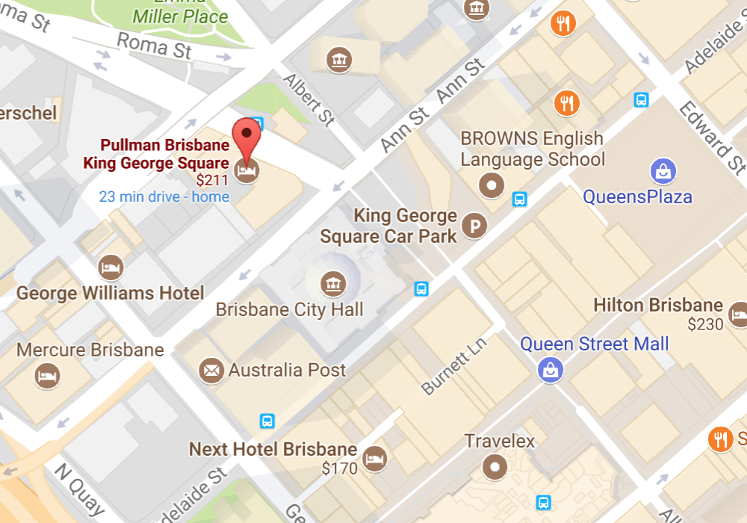

INSERT INTO `ich`.`inventory_hotel` (`title`, `address`, `openingHours`, `closingHours`, `description`, `image`, `city_id`) VALUES ('Sofitel', '249 Turbot St', '12:00am', '12:00pm', '429 elegantly appointed rooms and suites are complemented by the finest personal luxuries to make this one of Brisbane’s best accommodation experiences.', 'a', '1');

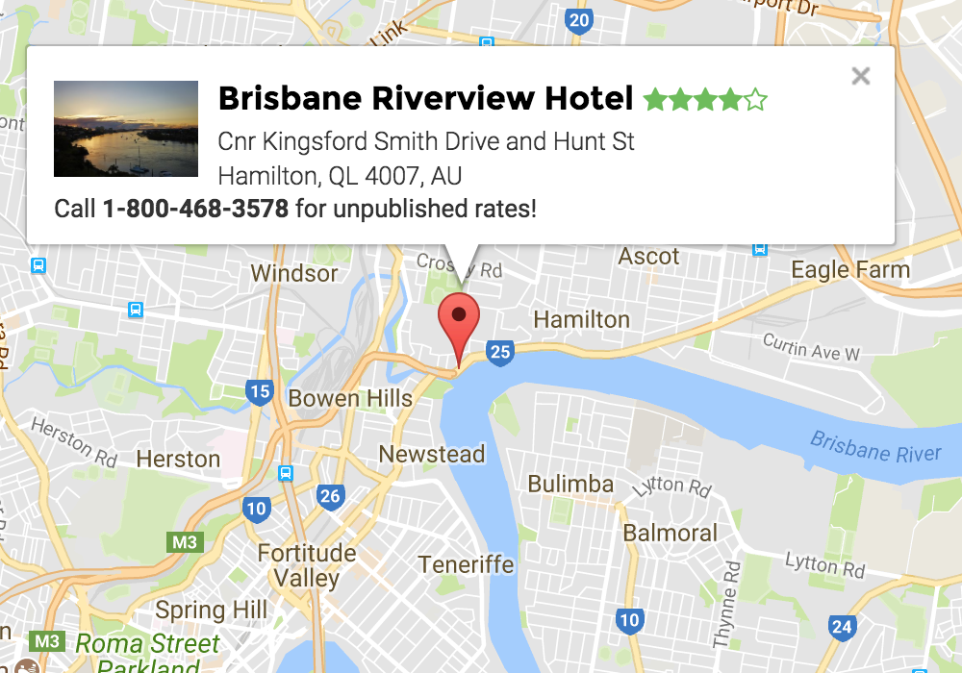

INSERT INTO `ich`.`inventory_hotel` (`title`, `address`, `openingHours`, `closingHours`, `description`, `image`, `city_id`) VALUES ( 'Hilton', '190 Elizabeth Street', '12:00am', '12:00pm', 'The hotel is located in the heart of a vibrant metropolitan area. This central Brisbane hotel is situated in an ideal location, only 30 minutes? drive from Brisbane Airport and a short walk from Central Station.', 'a', '1');

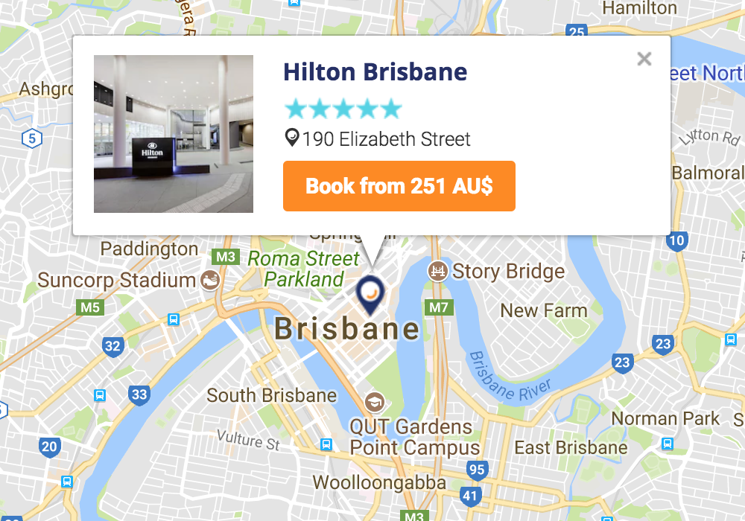

INSERT INTO `ich`.`inventory_hotel` (`title`, `address`, `openingHours`, `closingHours`, `description`, `image`, `city_id`) VALUES ('Stamford Plaza', 'Corner of Margaret & Edwards Streets.', '12:00am', '12:00pm', 'An exceptional place to stay!.', 'a', '1');

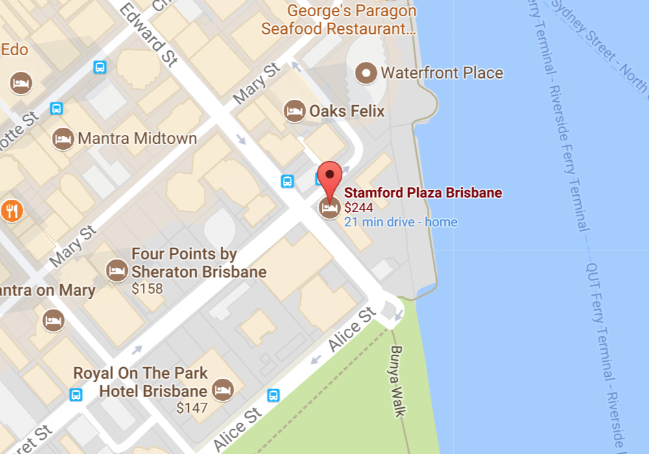

INSERT INTO `ich`.`inventory_hotel` (`title`, `address`, `openingHours`, `closingHours`, `description`, `image`, `city_id`) VALUES ('Marriott Hotel', '515 Queenstreet.', '12:00am', '12:00pm', 'Easy check in, centrally located and peaceful at night.', 'a', '1');

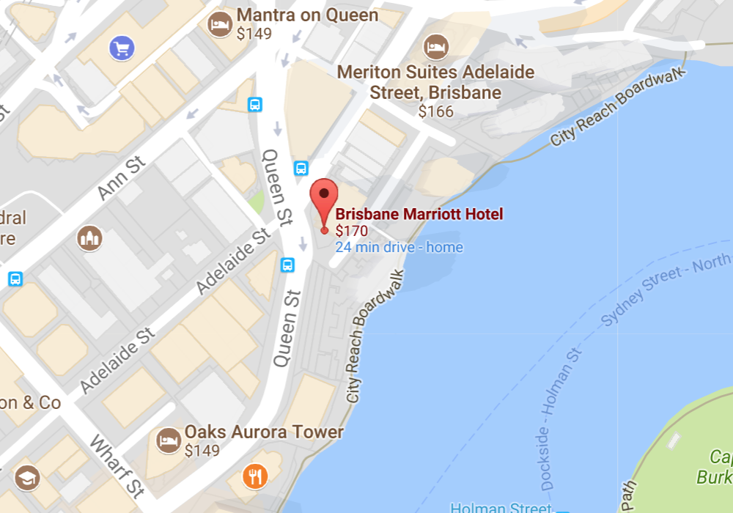

INSERT INTO `ich`.`inventory_hotel` (`title`, `address`, `openingHours`, `closingHours`, `description`, `image`, `city_id`) VALUES ('Brisbane Riverview Hotel', 'Cnr Kingsford Smith Drive and Hunt St, Hamilton, QL 4007.', '9:00am', '11:00pm', 'When you stay at Brisbane Riverview Hotel in Hamilton, you'll be on the waterfront and minutes from Albion Park Raceway and Newstead House. This 4.5-star hotel is within close proximity of Perry Park and Emporium.', 'a', '1');



**Library - Data**

INSERT INTO `ich`.`inventory_library` (`title`, `address`, `openingHours`, `closingHours`, `description`, `city_id`) VALUES ('QUT Library', '2 George St', '7:30am', '17:00pm', 'Great library for law books', '1');

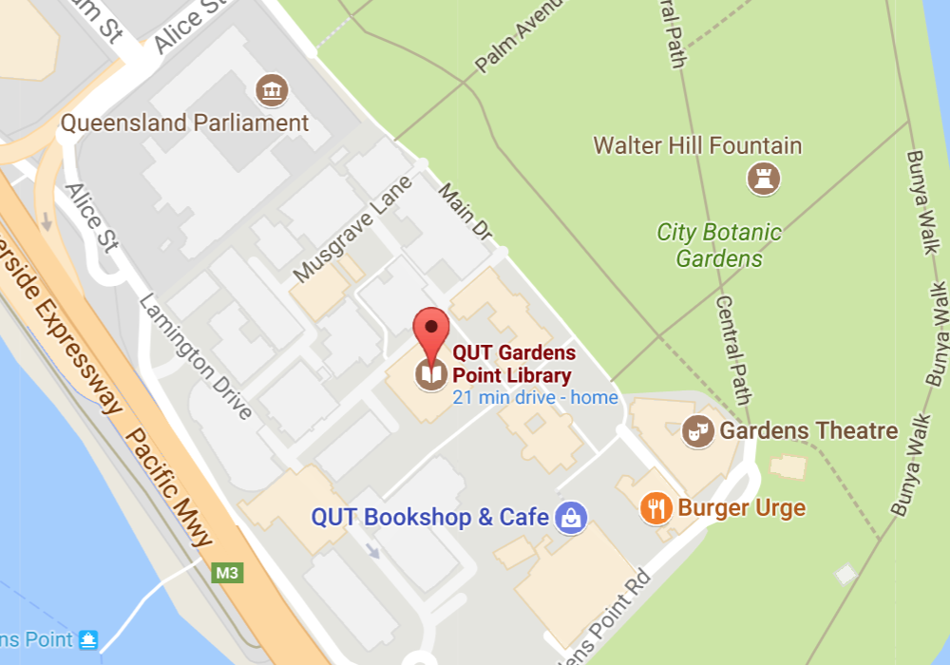

INSERT INTO `ich`.`inventory_library` (`title`, `address`, `openingHours`, `closingHours`, `description`, `city_id`) VALUES ('Brisbane Square Library', 'Brisbane Square, 266 George St', '9:00am', '6:00pm', 'A perfect place with some amazing atmosphere of mental growth and prestige.', '1');

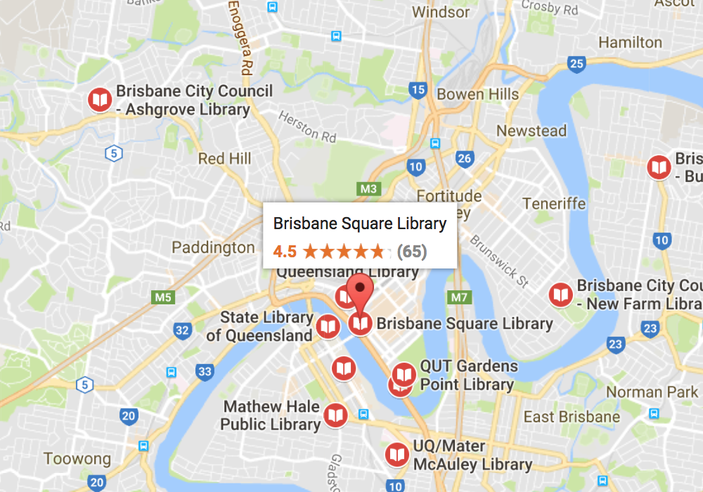

INSERT INTO `ich`.`inventory_library` (`title`, `address`, `openingHours`, `closingHours`, `description`, `city_id`) VALUES ( 'QUT Library', 'Stanley Pl, South Brisbane QLD 4101', '10:00am', '8:00pm', 'Great place. Fantastic ambience. Good collection and helpful staff.', '1');

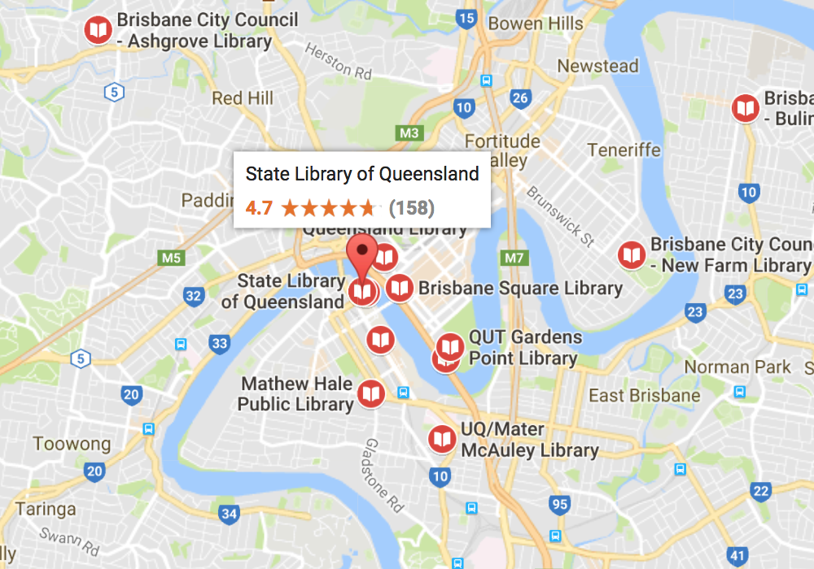

**Museum- Data**

INSERT INTO `ich`.`inventory_museum` (`title`, `address`, `openingHours`, `closingHours`, `description`, `city_id`) VALUES ( 'Queensland Maritime Museum', '412 Stanley St, South Brisbane', '9:30am', '4:30pm', 'It’s a great place to be for those who have a decent interest in history and have had a minimal exposure to real-time war equipment', '1');

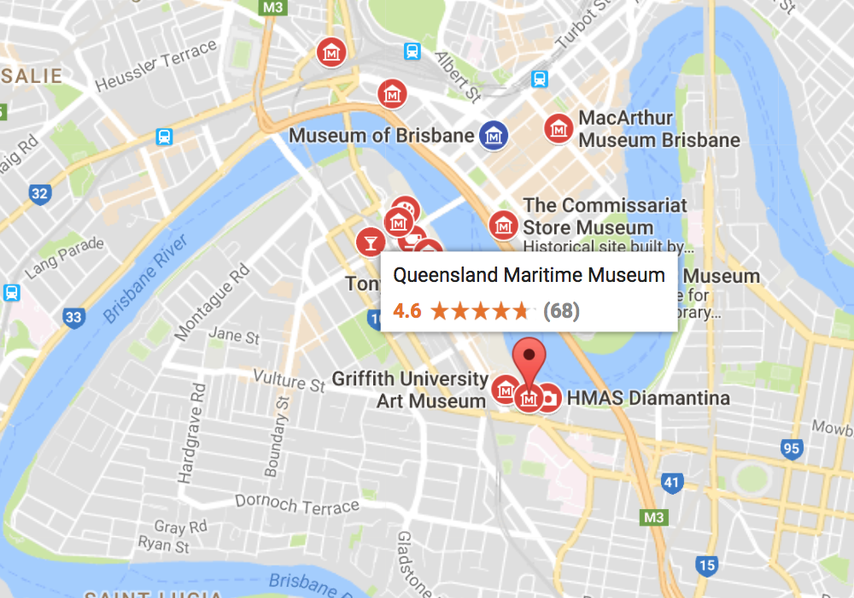

INSERT INTO `ich`.`inventory_museum` (`title`, `address`, `openingHours`, `closingHours`, `description`, `city_id`) VALUES ( 'Queensland Museum and Science Centre', 'Grey St & Melbourne St, South Brisbane ', '9:30am', '5:00pm', 'Museum featuring science, culture & natural history exhibits specific to the Queensland region, '1');

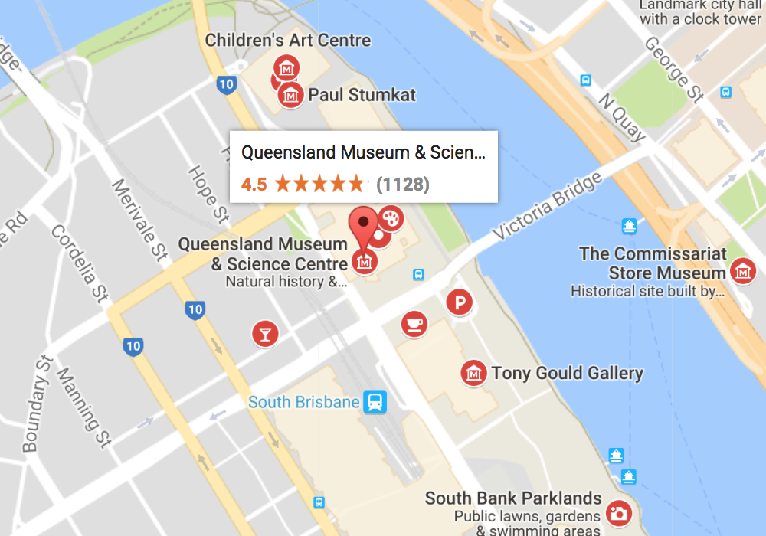

**Zoo - Data**

INSERT INTO `ich`.`inventory_zoo` (`title`, `address`, `openingHours`, `closingHours`, `description`, `city_id`) VALUES ( 'Lone Pine Koala Sanctuary', ': 708 Jesmond Rd, Fig Tree Pocket ', '9:00am', '5:00pm', 'Lone Pine Koala Sanctuary is an 18-hectare Koala Sanctuary in the Brisbane suburb of Fig Tree Pocket in Queensland, Australia. Founded in 1927, it is the world's oldest and largest koala sanctuary, '1');

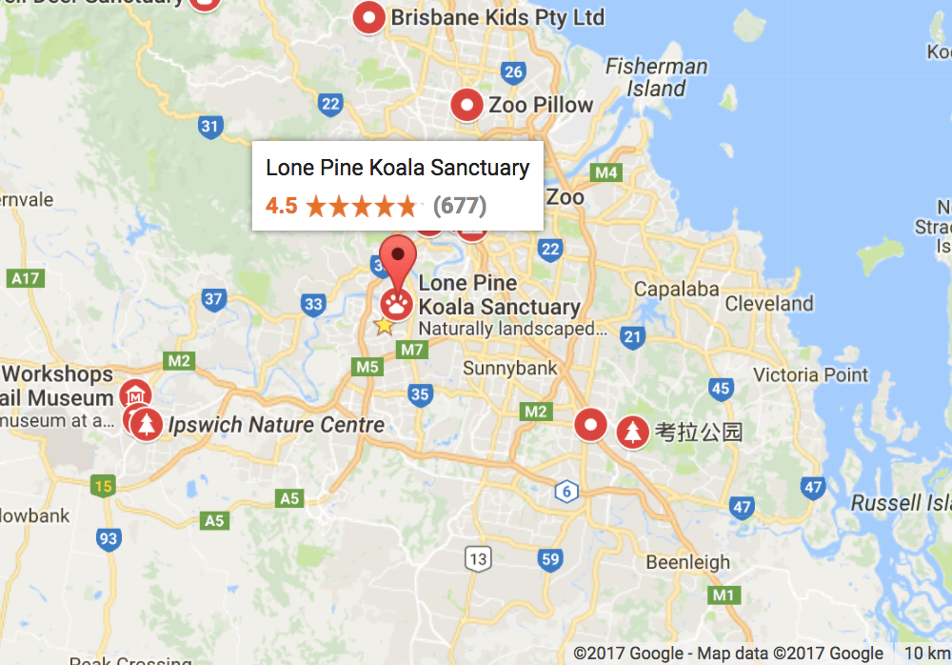

INSERT INTO `ich`.`inventory_zoo` (`title`, `address`, `openingHours`, `closingHours`, `description`, `city_id`) VALUES ( 'Australia Zoo', ': 1638 Steve Irwin Way, Beerwah ', '9:00am', '5:00pm', 'Australia Zoo is a 100-acre zoo located in the Australian state of Queensland on the Sunshine Coast near Beerwah/Glass House Mountains, '1');

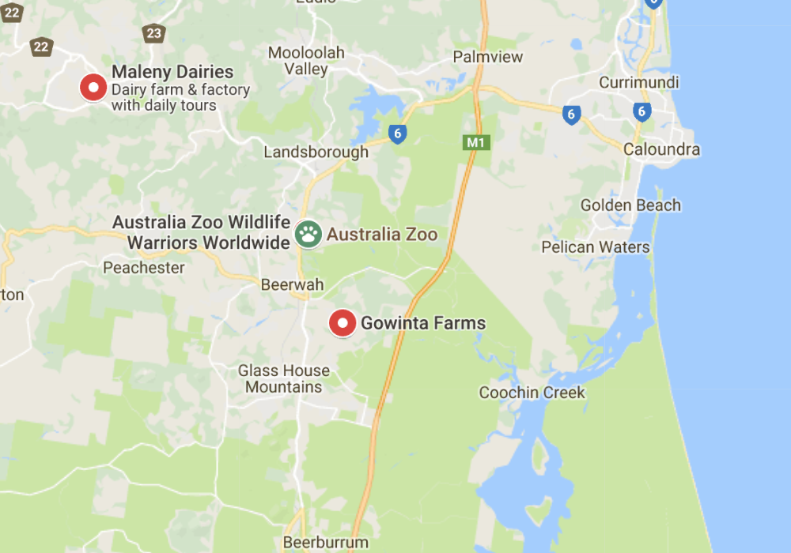

**Park - Data**

INSERT INTO `ich`.`inventory_park` (`title`, `address`, `openingHours`, `closingHours`, `description`, `city_id`) VALUES ('City Botanical Gardens, 'Alice St, Brisbane', '12:00', '12:00', 'Landmark botanical garden offering an array of plant life, ponds, picnic areas & a concert venue.', '1');

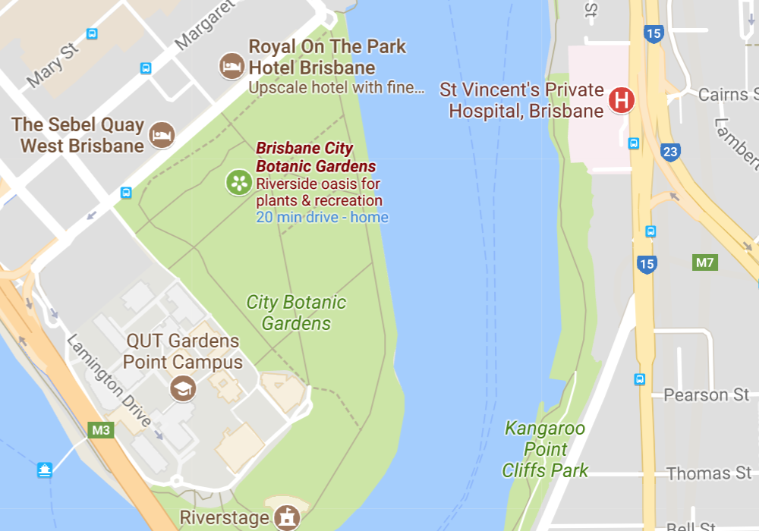

INSERT INTO `ich`.`inventory_park` (`title`, `address`, `openingHours`, `closingHours`, `description`, `city_id`) VALUES ('Brisbane Botanical Gardens- Mt Coot-tha, 'Mount Coot Tha Rd,', '8:00am', '5:00pm', 56-hectare, subtropical botanic gardens featuring native & exotic plants, plus workshops & events.', '1');

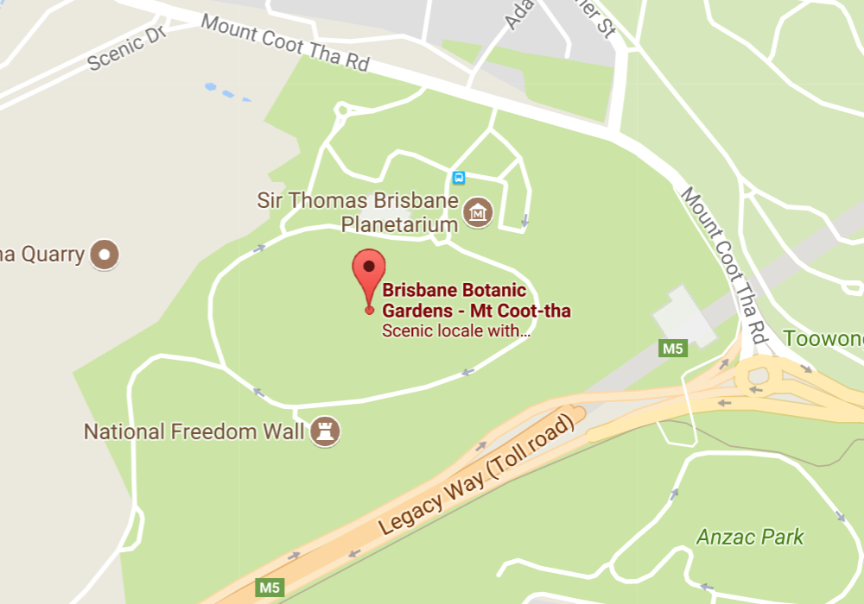

**Mall - Data**

INSERT INTO `ich`.`inventory_mall` (`title`, `address`, `openingHours`, `closingHours`, `description`, `city_id`) VALUES ('Queen Street Mall`, 'Queen Street mall, Queen St,', '12:00am', '12:00pm', 'Nice place to shop, walk, discover new music or eat.".', '1');

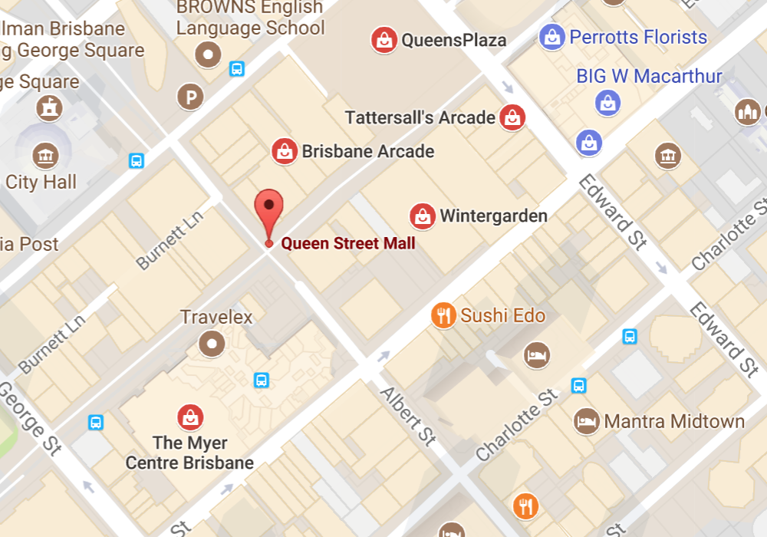

INSERT INTO `ich`.`inventory_mall` (`title`, `address`, `openingHours`, `closingHours`, `description`, `city_id`) VALUES ('The Myer Centre`, '91 Queen St, Brisbane City,', '9:00am', '9:00pm', 'Great staff and great selection of products.".', '1');

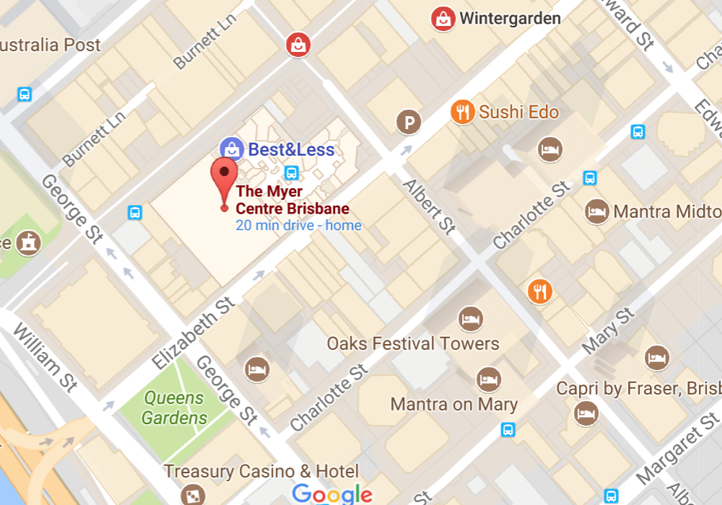

**Industry - Data**

INSERT INTO `ich`.`inventory_industry` (`title`, `address`, `openingHours`, `closingHours`, `description`, `city_id`) VALUES (`Mulrum Tech Pty Ltd`, 'Level 6/140 Creek St, Brisbane City QLD 4000, '8:30am', '5:00pm', 'Brisbane City tech Company.', '1');

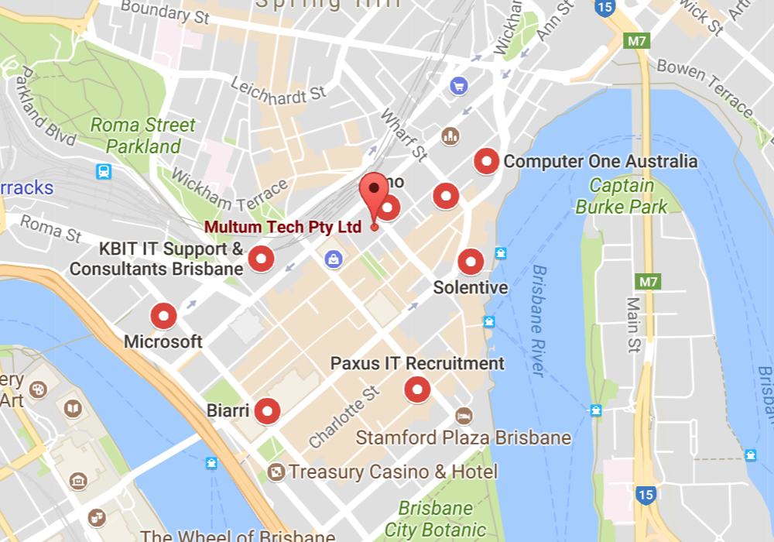

**Restaurant - Data**

INSERT INTO `ich`.`inventory_restaurant` (`title`, `address`, `openingHours`, `closingHours`, `description`, `city_id`) VALUES (`Jimmy’s on the Mall`, 'Queen St, Brisbane City QLD 4000', '12:00am', '12:00pm', 'Breezy, split-level venue with a leafy exterior open 24-7 for eclectic pub grub and boutique ales..', '1');

